Britannia University

Paduar Bazar , Bishwa Road ,Cumilla

**Project Report:** **Covid-19 website using an API .**

**Submitted To:**

Masum Bakaul

Lecturer ,Department of CSE

**Submitted By:**

Binta Nur Risha

ID:1801020022

Dept of CSE

**Introduction**

COVID-19 is a new disease, caused by a novel (or new) coronavirus that has not previously been seen in humans. Because it is a new virus, scientists are learning more each day. Although most people who have COVID-19 have mild symptoms, COVID-19 can also cause severe illness and even death.

On February 11, 2020 the World Health Organization [announced](https://twitter.com/DrTedros/status/1227297754499764230) an official name for the disease that is causing the 2019 novel coronavirus outbreak, first identified in Wuhan China. The new name of this disease is coronavirus disease 2019, abbreviated as COVID-19. In COVID-19, “CO” stands for corona, “VI” for virus, and ”D” for disease. Formerly, this disease was referred to as “2019 novel coronavirus” or “2019-nCoV.”

Coronavirus disease (COVID-19) is an infectious disease caused by a newly discovered coronavirus. Most people infected with the COVID-19 virus will experience mild to moderate respiratory illness and recover without requiring special treatment.  Older people , and those with underlying medical problems like cardiovascular disease, diabetes, chronic respiratory disease, and cancer are more likely to develop serious illness.

The best way to prevent and slow down transmission is to be well informed about the COVID-19 virus, the disease it causes and how it spreads. Protect yourself and others from infection by washing your hands or using an alcohol based rub frequently and not touching your face.

The COVID-19 virus spreads primarily through droplets of saliva or discharge from the nose when an infected person coughs or sneezes, so it’s important that you also practice respiratory etiquette (for example, by coughing into a flexed elbow).

I Build complete Dynamic Website against CORONA VIRUS . Here is a small contribution from my site, I have created a dynamic website using PHP and MySQL to spread awareness about Corona Virus and also a solution on how to help others by taking small steps towards the safety of each people living in Earth. On the live tracker page, build covid-19 live tracker using API with the number of confirmed cases, recovered patients, tests, and death to the covid-19 coronavirus. Let's stay Safe and be healthy.

This website have a header section and footer section. Also have a menu section. Home page , About page, live tracker page , contact page include this website. On the home page, I create spread awareness about coronavirus, Infected people symptoms, and also a solution on how to helps others by taking small steps towards the safety of each people living on earth. On the about page, have about coronavirus and also have section frequently asked question. On the live tracker page, build covid-19 live tracker using API with the number of confirmed cases, recovered patients, tests, and death to the covid-19 coronavirus. On the contact page, I will build a contact form section, address, subscribe form.

Benefits of “**covid-19 website**”

Having a website means users are always able to know information – anytime, anywhere. We will get a lot of benefits if we using the 'covid-19 website'

* Easy to Use.
* Simple and User Friendly Interface.
* Online Based.
* Faster Response.
* Time Saving.
* Cost Effective
* Secured
* live tracker using API

**Objectives**

For all countries, the final aim is the same: stop transmission and prevent the spread of the virus in order to save lives. We find all

* About Corona Virus
* Spread Corona Viruses
* Infected People Symtoms
* Corona Virus overview
* To Prevent the Spread of COVID-19

**Language/Technology Specifications**

**Language :**

* HTML
* CSS
* Bootstrap
* JavaScript
* jQuery
* PHP
* MySQL

**Proposed System’s Modules**

**covid-19 website** is divided into two modules:

* Admin Panel
* User site

**Admin Panel**

The Administrator application, also known as the Back-end, Admin Panel or Control Panel, is the interface where administrators and other site officials with appropriate privileges can manipulate web site. There are many tasks which can be done with the administrator interface. Admin Panel or Control Panel of **'covid-19 '** website

* Has the supreme power.
* Has controls upon the user(general) panel.
* Contact with users.
* Updates required information.
* Create admin registration
* Change his password
* Add, Delete ,edit information
* Generate message pdf file

**User site**

User will have known all information about covid-19

* User can know about covid 19
* Also know Spread Corona Viruses
* Infected People Symtoms
* Corona Virus overview
* To Prevent the Spread of COVID-19
* covid-19 live tracker using API with the number of confirmed cases, recovered patients, tests, and death to the covid-19 coronavirus.
* Newsletter website
* Contact

**Admin Panel Diagram**

Login

Contact Users

Updates

information

Control website



Add

Logout

Update

Delete

**Some Snap Shots of Admin Panel**

**Login:** Registered Admins can only login admin panel

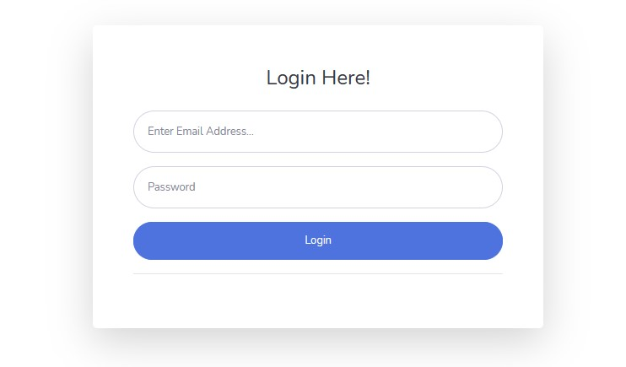

**Dashboard:** Here show total registered admin

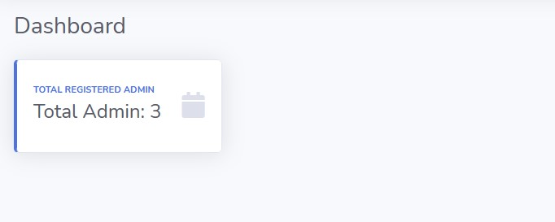

**Admin Profile**: Here shows Username , Email , Password of registered admins. And also have edit & delete option.

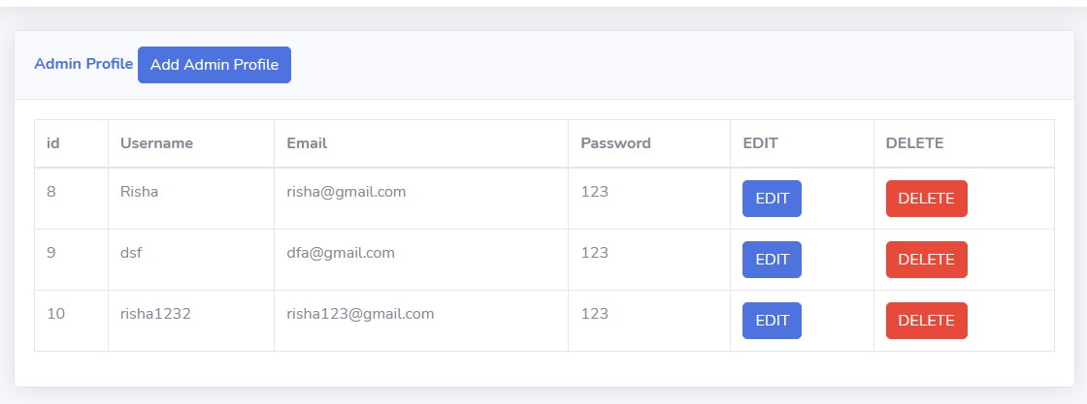**Add Admin Data :** New admin can register put there Username , Email , Password.

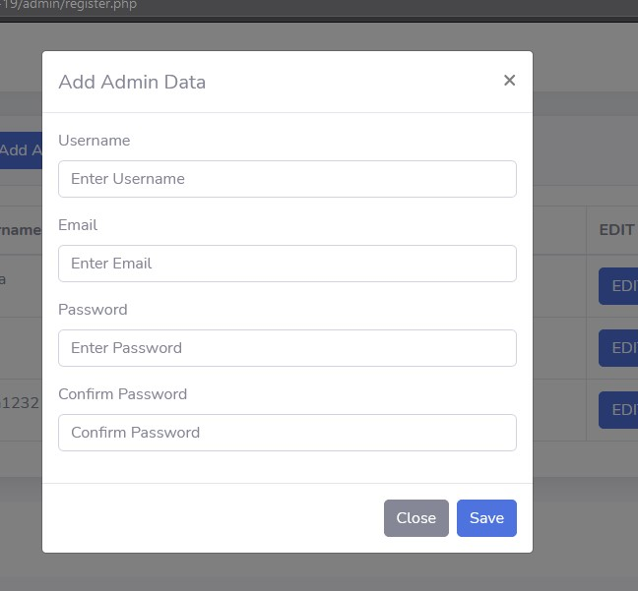

###### **EDIT Admin Profile :** Admin can edit there username, email and password.

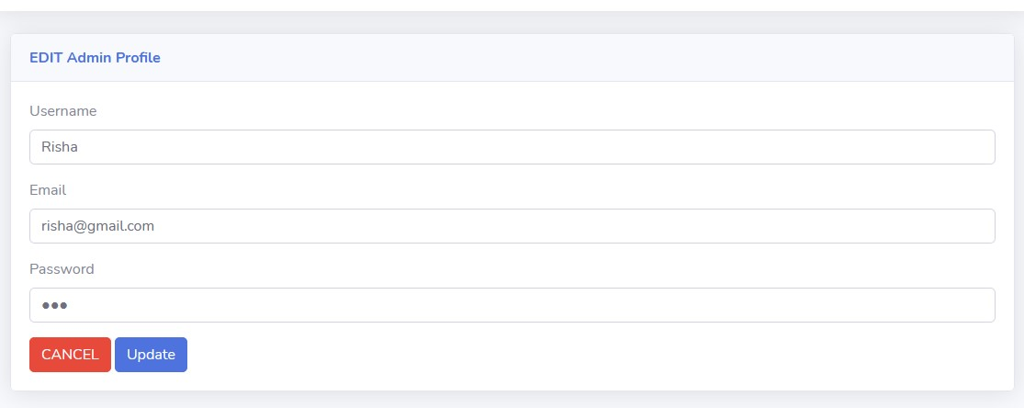

**Some Snap Shots of Home Page**

**Hero section :** In the Hero section admin can add content and image. And also have edit & delete option.

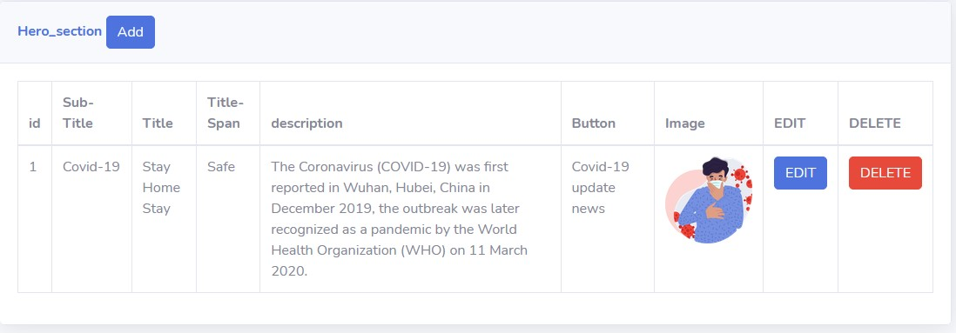

###### **Hero section:** This Hero section content shows the home page “hero” section

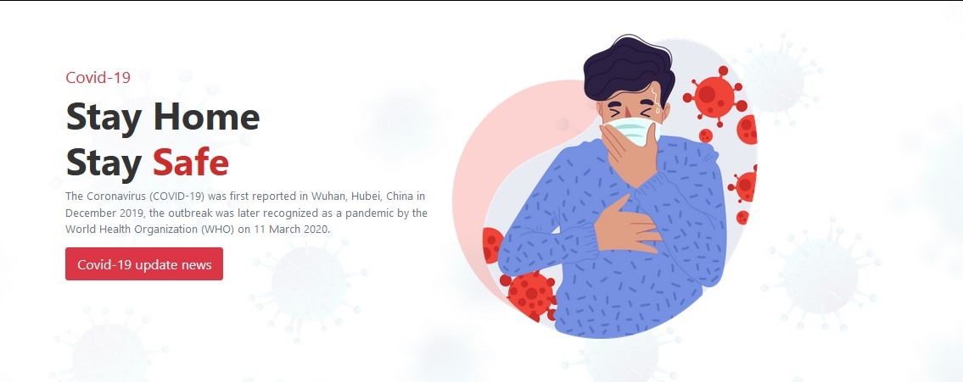

###### **About section** :In the about section admin can add content and image. And also have edit & delete option.

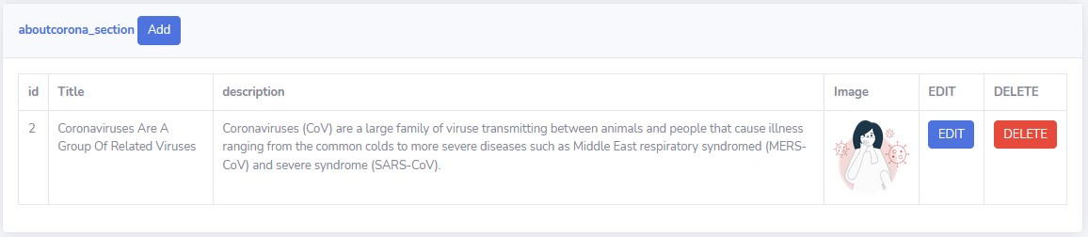

###### **About section:** This about section content shows the home page “about” section

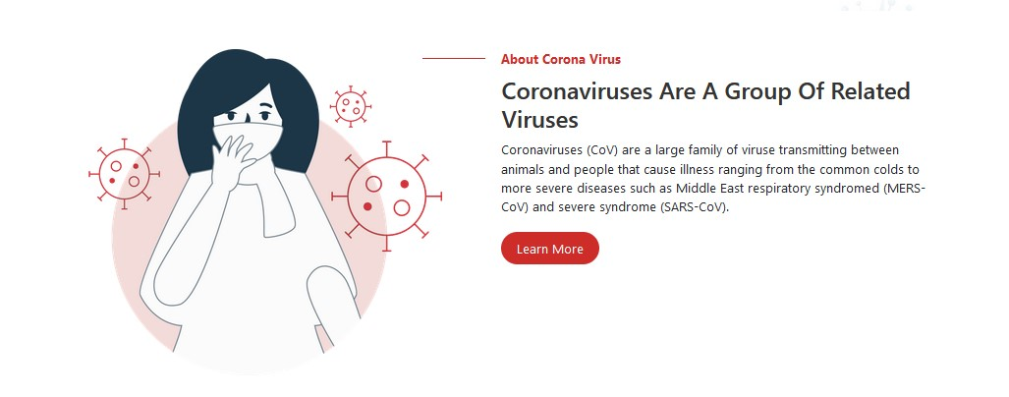

**Admin can add delete update information**

**Spread Section :**In the Spread Section admin can add title and image. And also have edit & delete option.

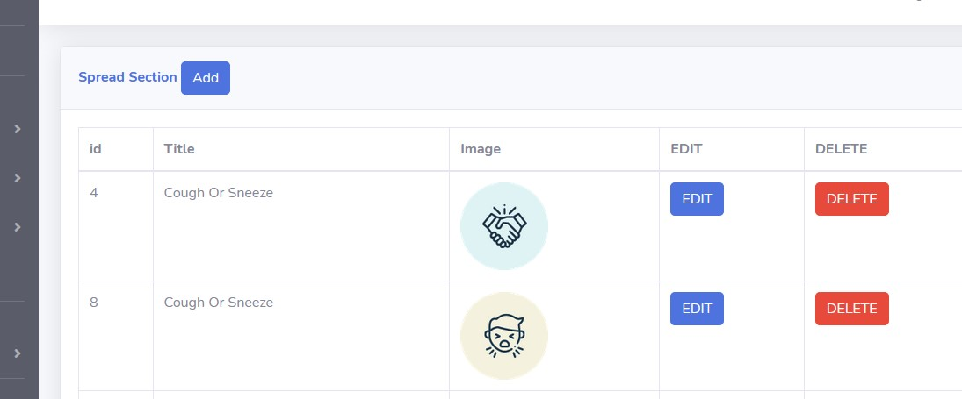

**Add:** admin can add title and image

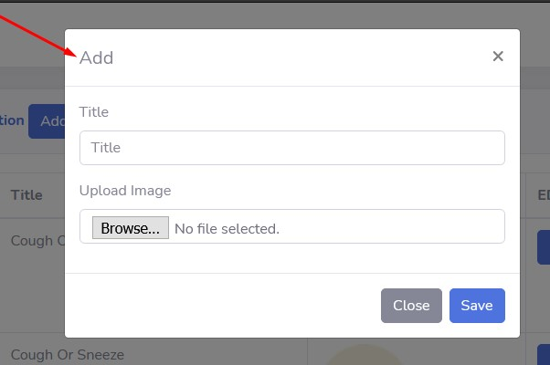

###### **EDIT Section :**Admin can edit title and image.

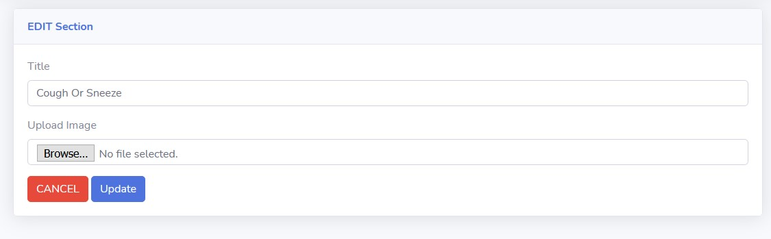

**Spread Section:** This Spread Section content shows the home page “Contagion” section

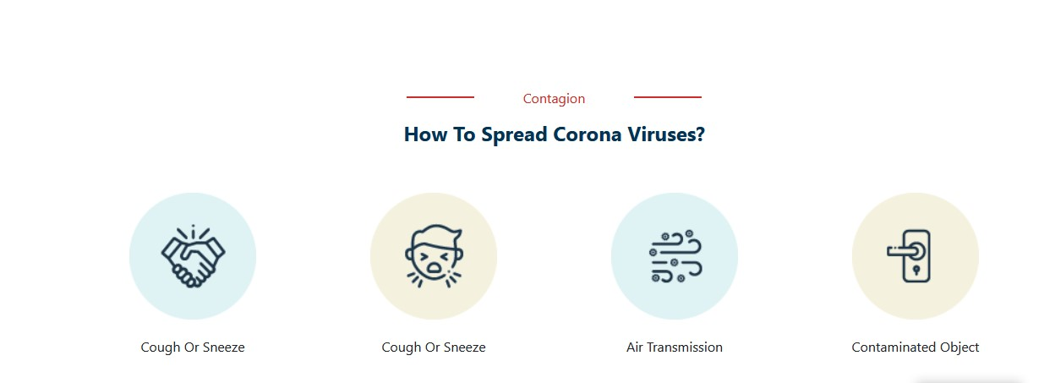

###### **Symtoms Section:** In the Symtoms Section admin can add title and image. And also have edit & delete option

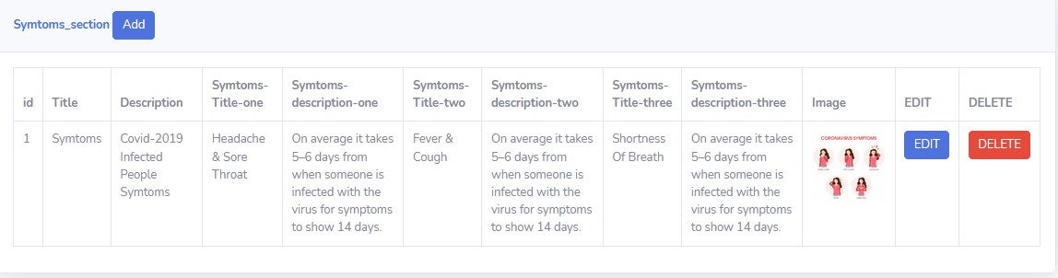

###### **Symtoms section:** This Symtoms section content shows the home page “Symtoms” section

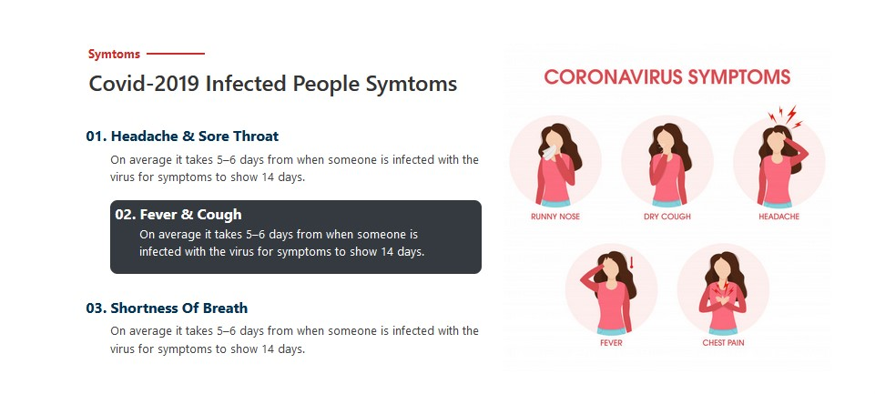

###### **Prevent Section :**In the Prevent section admin can add content and image. And also have edit & delete option.

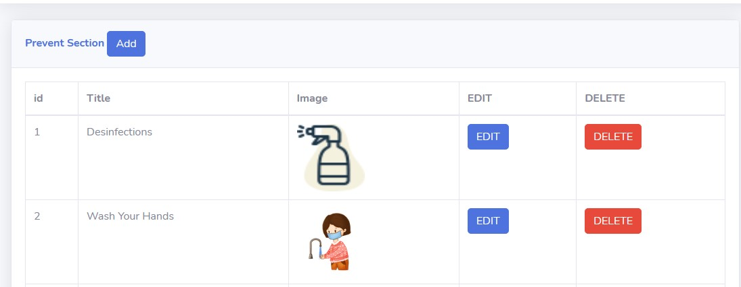

###### **Prevent section:** This Prevent section content shows the home page “Prevent” section

**Avoid section** :In the Avoid section admin can add content and image. And also have edit & delete opt**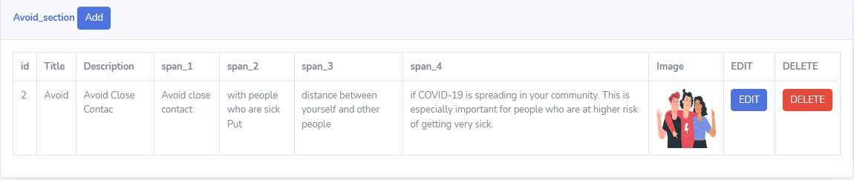*Avoid section:*** *This Avoid section content shows the home page “Avoid” section*

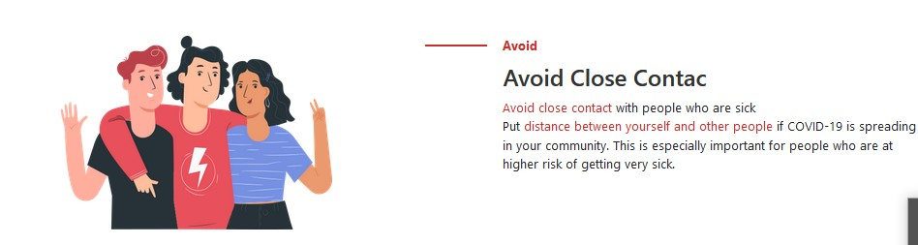

#### Corona Virus overview : Covid-19 live tracker using API with the number of confirmed cases, recovered patients and death to the covid-19

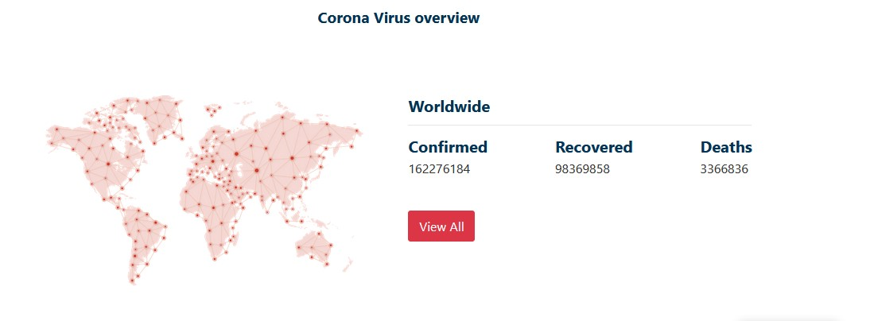

**Some Snap Shots of About Page**

**About section :**In the About section admin can add content and image. And also have edit & delete option.

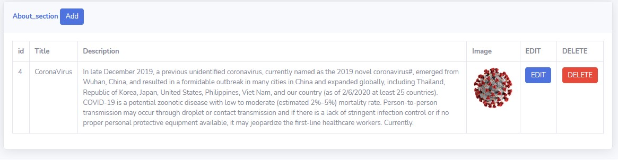

###### **About section:** This About section content shows the About page “About” section

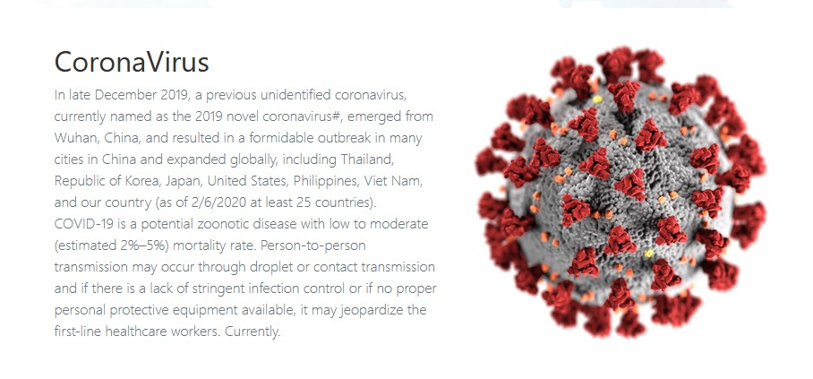**Section frequently asked question:**

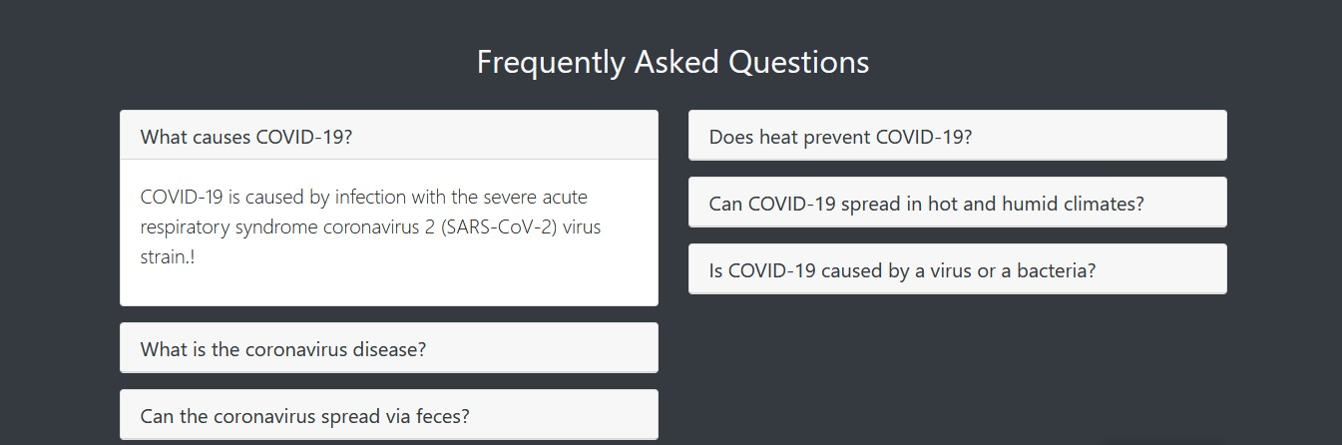

**Snap Shots of Covid-19 Update Page**

Covid-19 live tracker using API with the number of confirmed cases, recovered patients, tests, and death of the countries.

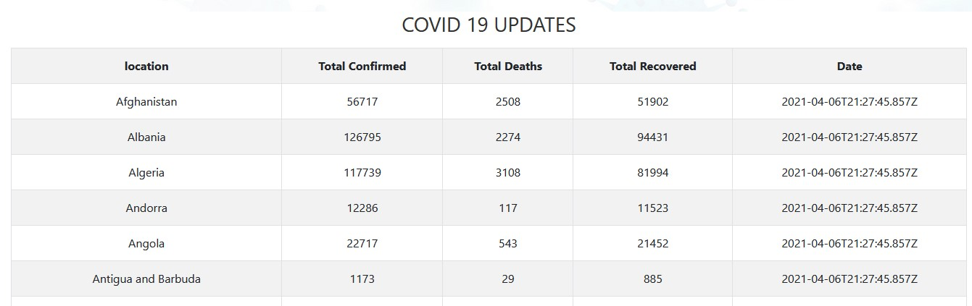

**Some Snap Shots of Contact Page**

Contact form section, address, subscribe form

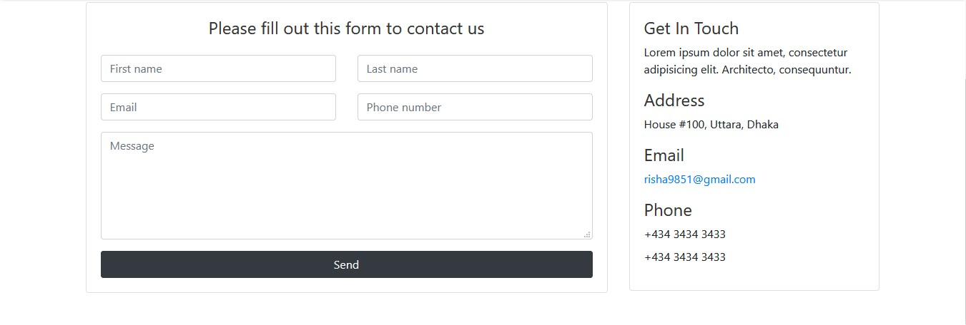

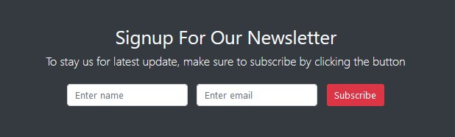

Admin can see user message, delete and also generate message a pdf file.

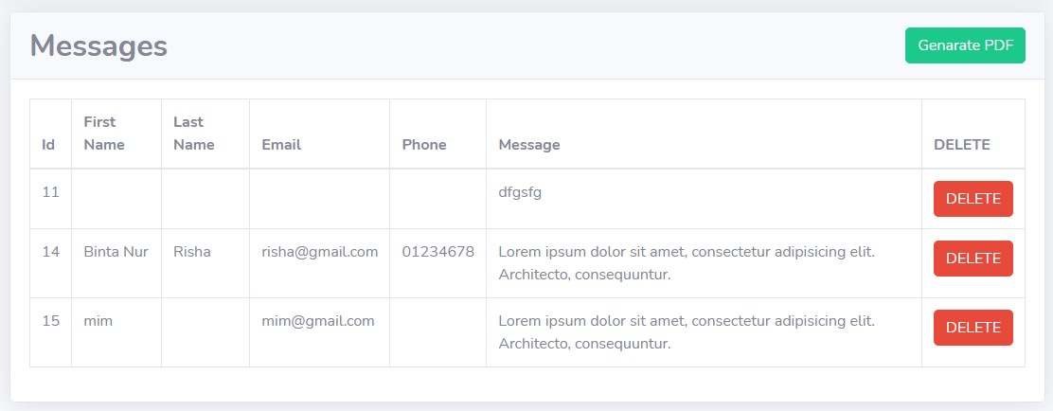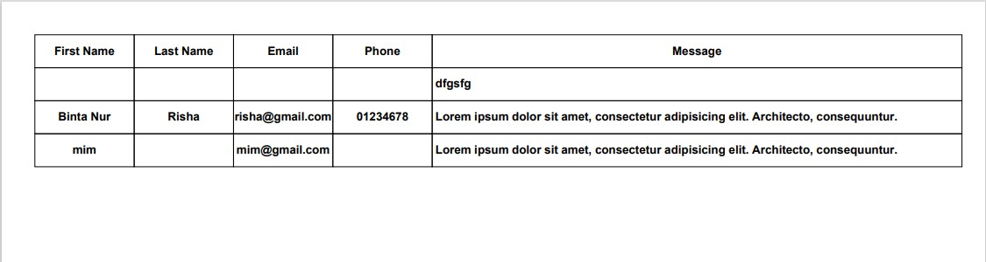

Admin can see user Newsletter email ,delete.

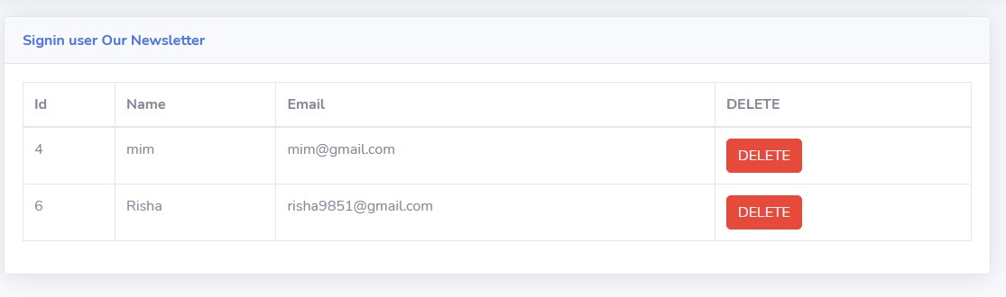

**Conclusion**

The building of this Project ”covid-19 website using an API” gave us the requisite practical knowledge to supplement the already taught theoretical concepts thus making me more competent as a computer engineer .The project from a personal point of view also helped me in understanding project development.